Screenshots PDF

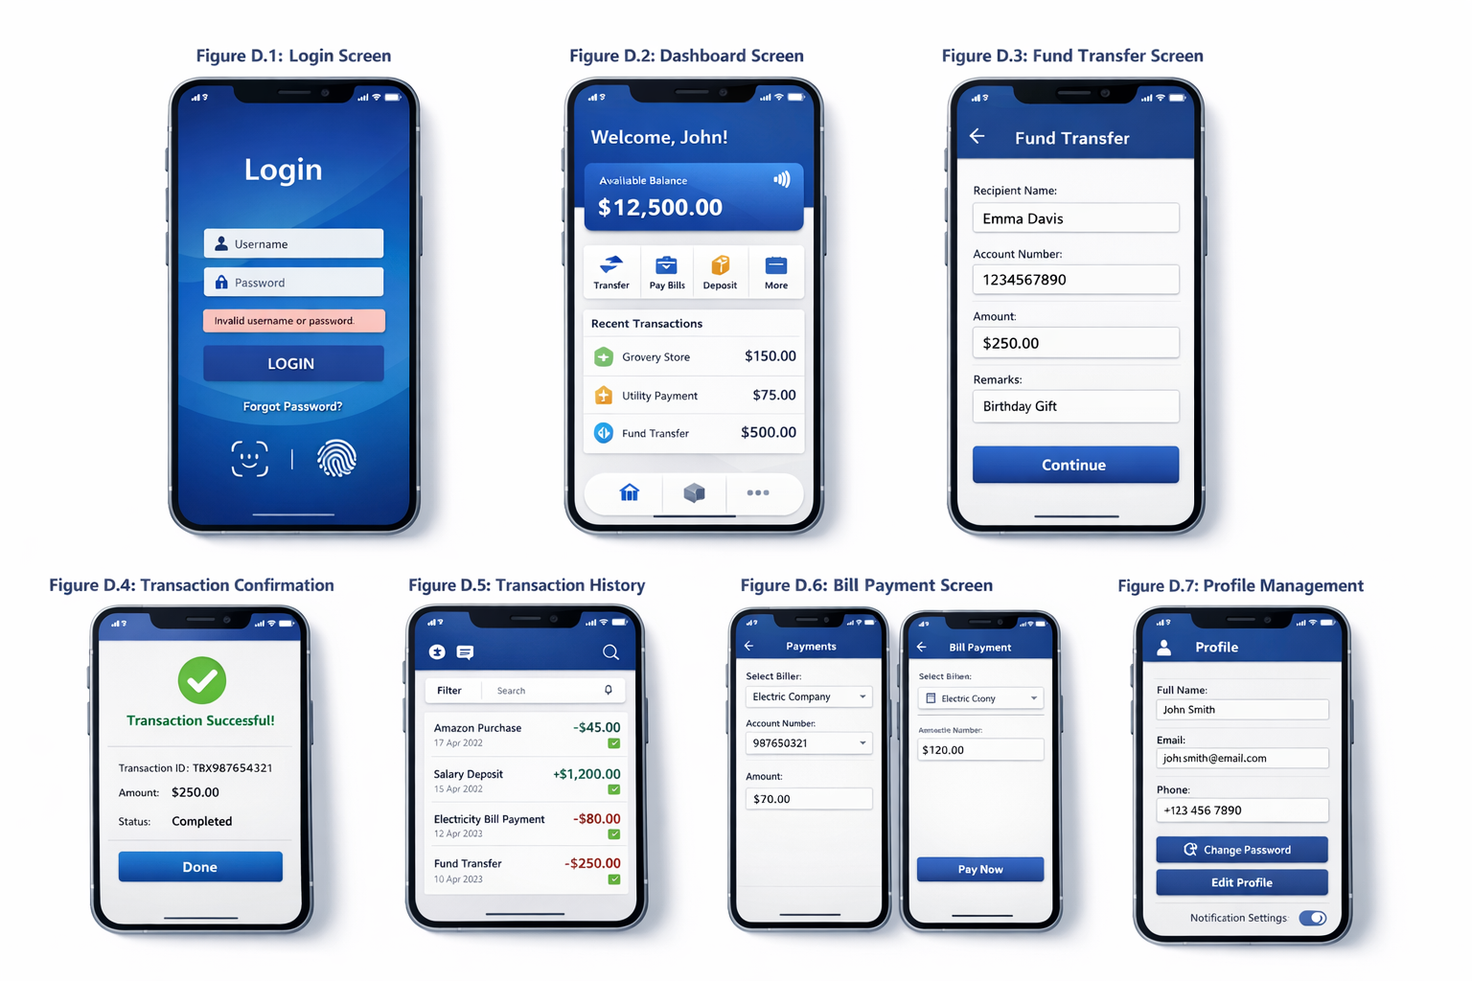
D.1 Dashboard Screen

Figure D.1: Login Screen
Description:
This screen allows users to securely log in using their username and password. It also supports biometric authentication for quick and convenient access. Error messages are displayed for invalid inputs to guide users and prevent login failures.
Detailed Flow of Login Process:
- The user opens the application and is presented with the login screen.
- The user enters valid credentials such as username and password.
- Alternatively, the user can choose biometric authentication (fingerprint/face recognition) for faster access.
- The system performs input validation to ensure that fields are not empty and follow the correct format.
- The entered credentials are verified against stored user data (simulated backend in this prototype).
- If the credentials are correct, the system initiates a secure session and redirects the user to the dashboard.
- If the credentials are incorrect, an appropriate error message is displayed, and the user is prompted to retry.
- In case of multiple failed attempts, the system may suggest password recovery for security purposes.
Additional Features and Highlights:
- Password masking is enabled to protect user privacy.
- “Forgot Password” option is provided for account recovery.
- Clear and minimal interface reduces user confusion.
- Proper spacing and alignment improve readability and usability.
- Visual feedback (such as error messages or loading indicators) enhances user interaction.
- Secure session handling ensures safe access to the application.


D.2 Dashboard Screen

Figure D.2: Dashboard Screen
Description:
The dashboard serves as the main control center of the application, providing an overview of the user’s account. It displays key information such as account balance, recent transactions, and quick access to essential services like fund transfer and bill payment.
Flow of Dashboard Interaction:
- After successful login, the user is redirected to the dashboard screen.
- The system fetches and displays the user’s account details, including available balance.
- Recent transactions are shown in a summarized format for quick review.
- The user can select quick action buttons (e.g., transfer, bill payment) to navigate directly to specific services.
- Notifications or alerts (if any) are displayed to inform the user about important updates.
- The user can navigate to other sections using the bottom navigation menu or shortcuts provided.
Additional Features and Highlights:
- Displays real-time account balance prominently for quick visibility.
- Provides quick access shortcuts to frequently used services, reducing navigation time.
- Shows recent transactions to improve transparency and user awareness.
- Uses a clean and structured layout to minimize cognitive load.
- Implements visual hierarchy to highlight important information first.
- Supports smooth navigation between different modules of the application.
- Includes notification/alert section for important updates.
- Designed with user-friendly icons and labels for better understanding.


D.3 Fund Transfer Screen
Figure D.3: Fund Transfer Screen
Description:
This screen enables users to transfer funds by entering beneficiary details and the transfer amount. It follows a structured, step-by-step approach to reduce errors, improve clarity, and ensure a smooth transaction experience.
Flow of Fund Transfer Process:
- The user selects the “Fund Transfer” option from the dashboard or navigation menu.
- The system displays the transfer form with required fields.
- The user selects or adds a beneficiary (recipient).
- The user enters essential details such as account number (if required) and transfer amount.
- Optional fields such as remarks or notes can be added for reference.
- The system performs input validation to ensure correct and complete data entry.
- The user reviews the entered details and clicks on the “Continue/Proceed” button.
- A confirmation screen or dialog is displayed before final submission.
- Upon confirmation, the system processes the transaction (simulated in prototype).
- The user is redirected to the transaction confirmation screen with status details.
Additional Features and Highlights:
- Step-by-step workflow reduces user confusion and prevents mistakes.
- Form validation ensures accurate data entry (e.g., valid amount, required fields).
- Pre-saved beneficiaries reduce effort and improve speed.
- Clear labeling of fields improves usability and understanding.
- Confirmation step enhances transaction safety and user confidence.
- Minimal and clean design reduces cognitive load.
- Error messages and prompts guide users in case of incorrect input.
- Designed to support quick and secure transactions with minimal steps.


D.4 Transaction Confirmation Screen
Figure D.4: Transaction Confirmation
Description:
This screen displays confirmation of a successful transaction, including details such as transaction ID, amount, date, and status. It provides clear feedback to the user and helps build trust by ensuring transparency and reliability of the transaction process.
Flow of Transaction Confirmation:
- After the user confirms a transaction (e.g., fund transfer or bill payment), the system processes the request.
- Once processing is complete, the user is redirected to the transaction confirmation screen.
- The system displays key transaction details such as:
- Transaction ID
- Amount transferred
- Date and time
- Transaction status (Success/Failed)
- A visual indicator (such as a success icon or message) is shown to clearly communicate the outcome.
- The user can review the details to ensure accuracy.
- The user can proceed by clicking a “Done” or “Back to Dashboard” button.
- The transaction is automatically recorded in the transaction history for future reference.
Additional Features and Highlights:
- Provides clear and immediate feedback after transaction completion.
- Displays unique transaction ID for tracking and reference.
- Uses visual indicators (e.g., success icon) to improve clarity.
- Enhances user trust and confidence in the system.
- Supports easy navigation back to dashboard or other services.
- Ensures transparency by showing complete transaction details.
- Designed to reduce uncertainty and confirm successful task completion.


D.5 Transaction History Screen
Figure D.5: Transaction History
Description:
This screen displays a comprehensive list of past transactions, allowing users to track their financial activities efficiently. It includes features such as search and filtering options to help users quickly locate specific transactions and review account activity with ease.
Flow of Transaction History Interaction:
- The user navigates to the Transaction History section from the dashboard or menu.
- The system retrieves and displays a list of past transactions in chronological order.
- Each transaction entry shows key details such as date, amount, type (credit/debit), and status.
- The user can scroll through the list to view more transactions.
- The user can use the search function to find specific transactions using keywords or amounts.
- Filters can be applied based on criteria such as date range, transaction type, or status.
- The user can select a specific transaction to view detailed information.
Additional Features and Highlights:
- Displays organized transaction records for better financial tracking.
- Supports search functionality for quick access to specific transactions.
- Provides filter options to refine results based on user needs.
- Clearly differentiates credit and debit transactions.
- Uses a clean and readable layout to improve user understanding.
- Enhances transparency and trust by providing complete financial history.
- Enables users to review and verify past activities easily.
- Designed for efficient navigation and minimal effort.


D.6 Bill Payment Screen
Figure D.6: Bill Payment Screen
Description:
This screen allows users to pay bills by selecting appropriate bill categories, choosing saved billers, and completing payments quickly with minimal steps. The design focuses on simplicity and efficiency to ensure a smooth and hassle-free payment experience.
Flow of Bill Payment Process:
- The user selects the “Bill Payment” option from the dashboard or navigation menu.
- The system displays various bill categories such as electricity, mobile recharge, water, and DTH.
- The user selects a category or chooses from saved billers for faster processing.
- The user enters or verifies the required details such as bill amount or account number.
- The system performs input validation to ensure correctness of details.
- The user reviews the payment information and clicks on the “Proceed/Pay” button.
- A confirmation screen or dialog is displayed before final submission.
- Upon confirmation, the system processes the payment (simulated in prototype).
- The user is redirected to the transaction confirmation screen with payment status.
Additional Features and Highlights:
- Supports multiple bill categories for different services.
- Provides saved billers to reduce repetitive data entry.
- Ensures quick and efficient payments with minimal steps.
- Includes validation checks to prevent incorrect inputs.
- Uses clear labels and structured layout for easy understanding.
- Provides confirmation step to enhance transaction safety.
- Displays instant feedback after payment completion.
- Designed to improve user convenience and reduce effort.


D.7 Profile Management Screen
Figure D.7: Profile Management
Description:
This screen allows users to view and manage their personal information, update profile details, change passwords, and customize application settings. It provides users with control over their account information while ensuring security and ease of use.
Flow of Profile Management:
- The user navigates to the Profile section from the dashboard or menu.
- The system displays the user’s personal information such as name, mobile number, and email.
- The user can choose to edit profile details by selecting the edit option.
- Updated information is entered and validated by the system.
- The user can access the change password option to update login credentials securely.
- The system verifies the current password before allowing a new password to be set.
- The user can manage application settings such as notifications and preferences.
- Once changes are saved, the system updates the data and provides confirmation feedback.
Additional Features and Highlights:
- Allows easy viewing and editing of personal information.
- Provides secure password change functionality.
- Includes input validation to ensure correct data entry.
- Supports customization of app settings and preferences.
- Displays clear confirmation messages after updates.
- Ensures data privacy and security during profile changes.
- Designed with a simple and user-friendly interface.
- Enhances user control and overall application experience.

